3. Facilitation payments

The rules on the prohibition of corruption also apply without exception to so-called facilitation payments, as these are equally detrimental and usually pave the way for even more serious corruption issues. At the same time, Siemens has an obligation to ensure safe working conditions.

|  |
| --- |
| General principles  Facilitation payments are prohibited.  However, no employees are expected to risk life, limb or liberty in the course of performing their duties. Unjustified payments under duress will not be punished with disciplinary action.  They must be reported in accordance with this section which also contains more detailed guidance. |

Definitions:

A “*facilitation payment*” is the payment of a relatively small amount of money or the granting of any other benefit to usually low-ranking government officials, for their own personal benefit, with the aim of speeding up the performance of an official act to which the person making the payment/granting the benefit is entitled. This means that the government entity concerned would perform the official act in the same form and in any event, without payment to the government official (including, for example, granting approval where all preconditions are satisfied).

Both legally protected interests must therefore be considered when a situation of duress for Siemens employees arises. A “*situation of duress*” is a situation in which employees have no alternative but to make an unjustified payment in order to protect themselves or others against the threat of death, injury or loss of personal liberty. The “*threat*” must be tangible and manifest. A theoretical possibility does not qualify as duress[1]. “*Loss of personal liberty*” applies where there is a threat of imprisonment or comparable sanctions[2].

## 3.1. Prohibition of facilitation payments

Facilitation payments are prohibited by law in practically all countries as a form of corruption.

Legal exceptions in certain jurisdictions (such as Australia, South Korea and the USA) do not legalize facilitation payments as such, but merely exclude criminal prosecution, for example by the US authorities for facilitation payments effected outside the USA. Facilitation payments to government officials in the USA are forbidden and liable to criminal prosecution.

All Siemens employees are prohibited from offering, promising or making facilitation payments[3]. No such authorization will be granted. The same applies to payments or the granting of other benefits of comparable characteristics and with a comparable purpose to private commercial counterparties.

This prohibition may not be circumvented by making facilitation payments indirectly through third parties[4]. When working with third parties, employees must therefore look out for any indications, for example on invoices, that such third parties may have made or may be making facilitation payments in the context of their activities for Siemens.

## 3.2. Exceptions

In many jurisdictions, a payment under duress is not deemed an act of corruption. In other countries, a situation of duress is at least recognized as justification or as grounds for exemption from punishment. Correspondingly, no Siemens employees are expected to risk life, limb or liberty in the course of performing their duties. Unjustified payments under duress will therefore not be punished with disciplinary action under the following conditions:

* Any employee should ask the person demanding the payment to explain the legal basis for the demand and inquire whether an official account or receipt will be issued for the payment[5].
* If it becomes evident that the payment demanded most likely constitutes a facilitation payment, either because there is no plausible legal basis for such payment or because the government official refuses to issue an official invoice or receipt, the employee should oppose the demand as strongly as possible.
* If a situation of duress arises, it is permissible to yield to the request to make a facilitation payment. Expenditure in connection with facilitation payments is generally not reimbursed to employees or third parties acting for Siemens[6].

Provided that

* the employee has complied in full with the applicable reporting and documentation obligations and
* there are no specific circumstances indicating that the employee is at fault in connection with the payment,

disciplinary action will generally be disproportionate because the employee will have allowed Siemens to meet its statutory documentation duties.

## 3.3. Documentation and reporting

The request to make the payment must be reported to the [responsible Compliance Officer](https://intranet.for.siemens.com/cms/059/en/about/regions/Pages/compliance_regions-countries.aspx) without undue delay. The same applies if a third party acting for Siemens is suspected of having made facilitation payments or payments under duress in the context of its activities for Siemens.

All facts[7] must be recorded as soon as possible after the incident in a brief written report. This report must be submitted to the responsible Compliance Officer.

The Compliance Officer reports the incident in TRACI under the “Active Corruption” category, subcategory “Public Corruption Active”. To allow for easy identification, “FP” should be added in front of the case name[8]. In the case of a payment by a third party acting for Siemens, the report is produced by the responsible Compliance Officer in coordination with the third party concerned.

The Compliance Officer informs the management of the Regional Company and the General Counsel as soon as possible of every incident. The management of the Regional Company decides in consultation with the General Counsel and the responsible Compliance Officer whether the incident should be reported and, if so, to which local authority.

The management, together with the General Counsel and the Compliance Officer, decides on any further proceedings with the authority that requested the payment[9]. The responsible Compliance Officer advises the management of the Regional Company with regard to potential countermeasures for the future.

## 3.4. Reimbursement of expenditure

Payments made under duress can be accounted for and reimbursed (for employees, this takes place within the framework of the travel expense reimbursement procedures), provided that

* the employee has properly documented a situation of duress and
* the [responsible Compliance Officer](https://intranet.for.siemens.com/cms/059/en/about/regions/Pages/compliance_regions-countries.aspx) has confirmed the situation of duress.[10]

## 3.5. Risk identification, monitoring and mitigation

The [responsible Compliance Officers](https://intranet.for.siemens.com/cms/059/en/about/regions/Pages/compliance_regions-countries.aspx) provide risk analyses concerning the occurrence of facilitation payments in their respective areas. They ensure that employees particularly exposed to risk receive appropriate training, with special regard to correct conduct in situations of duress.

All incidents must be reported immediately by the [responsible Compliance Officers](https://intranet.for.siemens.com/cms/059/en/about/regions/Pages/compliance_regions-countries.aspx) to Chief Compliance Officer and the Chief Counsel Compliance.

## 3.6. Training and supporting material

Further information can be found on the [Facilitation Payments Intranet page](https://intranet.for.siemens.com/cms/059/en/processes/publications/Pages/compliance_facilitation-payments.aspx).

Quick guide “Do´s and Don’t´s”

The following quick guide summarizes the “[Do´s and Don’t´s](https://findit.compliance.siemens.com/content/10000101/Compliance/CL_CO/CL_CO_AT/findIT_CL_CO_AT_2272.pdf)” in terms of facilitation payments and shows which behavior is suggested in this context and which should be avoided if possible:

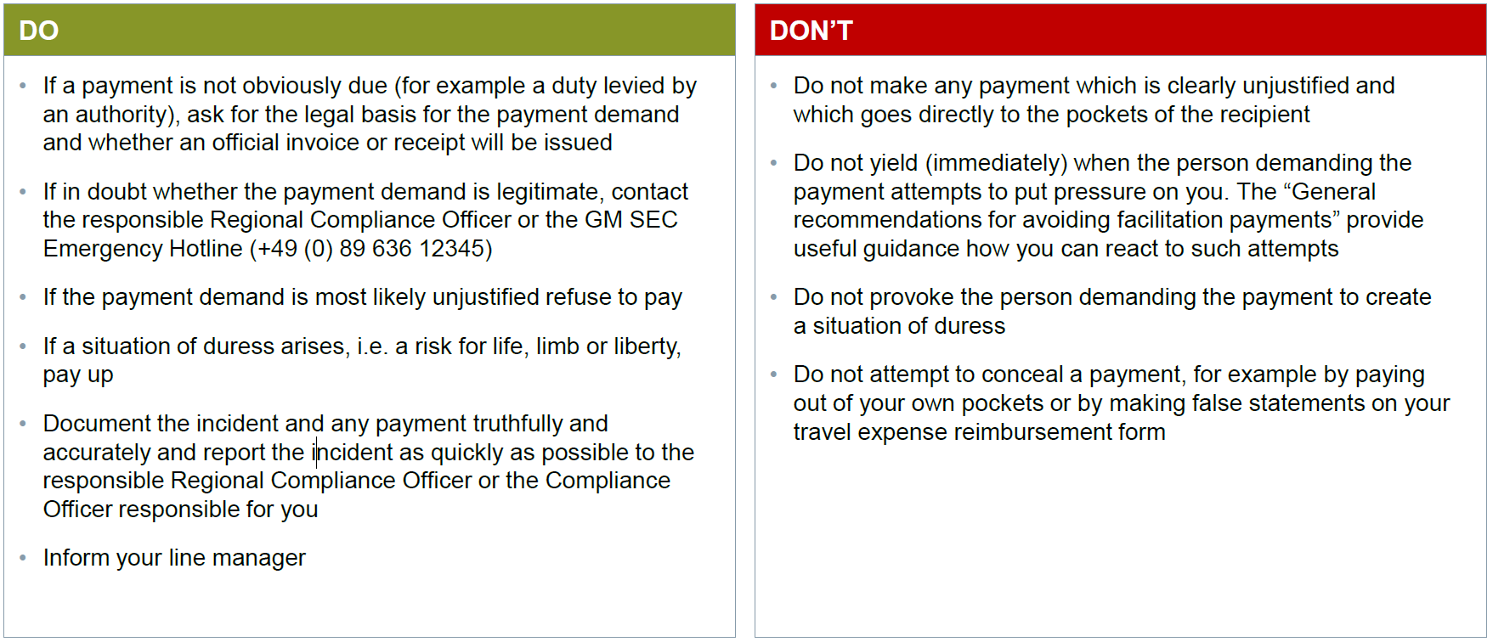

General recommendations for avoiding facilitation payments

Furthermore the [“General recommendations for avoiding facilitation payments”](https://findit.compliance.siemens.com/content/10000101/Compliance/CL_CO/CL_CO_AT/findIT_CL_CO_AT_2269.pdf) can give more information in which general recommendations are given, on how to behave overseas in order to avoid a payment claim, how to react when faced with such a demand and how to proceed when the required payment cannot be avoided.

Siemens Emergency Hotline (+49 89 636 12345)

Should a Siemens employee, during a business trip or business stay abroad, find himself in the situation of being asked to make a facilitation payment, he can obtain suitable 1st level support by calling the Siemens Emergency Hotline.

Facilitation Payments as an awareness topic for Siemens

Additional information based on a concrete case study on the subject of facilitation payments as an awareness topic can be found in the presentation [“Awareness Topic Facilitation Payments”.](https://findit.compliance.siemens.com/content/10000101/Compliance/LC_CO/LC_CO_STR/findIT_LC_CO_STR_4880.pdf)

## 3.7. History of changes

|  |  |  |
| --- | --- | --- |
| **Date** | **Author** | **Major changes of binding content** |
| January 1, 2019 | Christina Wolfgramm  Thomas Mark | First Release through the Compliance Handbook based on former Siemens Circular SC No. 226 “Global Compliance” Appendix 2. |
| January 1, 2020 | Yvonne Hamm-Düppe | Siemens Emergency Hotline added |

## 3.8. Contacts

Compliance Officer

The Compliance Officer responsible for your unit can be found through the following [link](https://intranet.for.siemens.com/cms/059/en/about/org/Pages/compliance_organization.aspx).

Content Owner

[Ralph Nohe (LC CO PT CO)](https://scd.siemens.com/luz/IdentitySearch?cn=nohe%2C+ralph&suchart=schnell)

[Martin Felkl (LC CO RFC RC)](https://scd.siemens.com/luz/IdentitySearch?cn=felkl%2C+martin&suchart=schnell)

Corporate Governance Owner

[Christina Wolfgramm](https://scd.siemens.com/luz/IdentitySearch?cn=WOLFGRAMM+CHRISTINA+Z002BPMD&tcgid=Z002BPMD&c=DE&o=SIEMENS&ou=LC&l=MCH+P&department=LC+CO+RFC+LF&&utI=I&utX=X&utT=T&rtH=H&rtS=S&rtZ=Z&rtO=O&rtAktiv=A) (LC CO RFC LF)

1. For example, if an armed government official is demanding payment without actually using his weapon to make a threat.
2. A mere delay in exit or onward travel procedures, caused for example by a refusal to perform customs clearance or objection to a visa in the context of passport control, is generally not sufficient to give rise to a situation of duress.
3. Business Conduct Guidelines, section G1.
4. For example consultants, agents, intermediaries, other service providers or business partners.
5. The Regional Compliance Officer and the CSO Hotline +49 (89) 636 12345 can assist in clarifying whether or not the demand is justified in the case concerned.
6. For exceptions please see section 5.2. of this section below.
7. The circumstances and subject matter of the demand, as well as the persons involved and their reaction to the refusal to pay.
8. The Compliance Officer reports the incident in TRACI under the “Active Corruption” category, subcategory “Public Corruption Active”. To allow for easy identification, “FP” should be added in front of the case name.
9. It is conceivable, for example, to issue a formal request to the authority that employs the recipient of the payment to provide an official invoice or receipt for the amount paid and/or to submit a claim for the recipient to return payment to the authority that employs the recipient of the payment or to a higher-level authority.
10. The [Compliance Officer](https://intranet.for.siemens.com/cms/059/en/about/regions/Pages/compliance_regions-countries.aspx) ensures that any reimbursement paid by the company is booked onto the account number 8311 Other Transfer of Class 8 "other income" to Class 6 and transfer of Class 6 "expenses" to Class 8.